**Project Overview**

Pianos are large instruments that cannot be carried everywhere. Even electric pianos need to be carried in a large bag and are prone to damage in travelling. So here we propose a portable virtual piano that just uses semi-transparent plastic sheet that can be carried and does not have any electronic components in it. We use a raspberry pi attached to a camera along with the plastic sheet to make a virtual piano. We use image processing to divide the plastic sheet into sections and assign particular tomes to it. We the detect human fingers through the plastic sheet and simulate associate piano tone for each section to play piano tones using a speaker. Thus, we provide a virtual piano which is actually a transparent light weight plastic board that can be carried around roughly.

**Need Analysis**

Piano is almost certainly the largest and most complex mechanical device. A standard piano as 230 strings and about 10,000 separate moving parts. Moving it from one home to another without the utmost care can easily cause unforeseen problems. Hence Pianos are large instruments that cannot be carried everywhere. Even electric pianos need to be carried in a large bag and are prone to damage in travelling. So here we propose a portable virtual piano that just uses semi-transparent plastic sheet that can be carried and does not have any electronic components in it.

**Literature Survey**

There are many previous works relevant to this paper, including several with a specific focus on piano tutoring with computer vision. Furthermore, there is a significant amount of existing work with an emphasis on finger detection and/or piano playing technique; however, there are relatively few papers which look at keyboard detection in detail – as is the primary technical focus of this paper.

We began by examining the recent papers from the University of Canterbury, where work, similar to that proposed in this paper, has been developed in the past. For example, Lang produced a webcam-based piano application – however the focus of this was on entertainment, not education, and there was no attempt made to detect the keyboard or keys of a real piano.

Deaker proposed a piano tutoring system which would test the user’s knowledge by asking them to play particular notes or chords on a paper keyboard with a printed design. Deaker’s proposal is similar to ours in that it requires the detection of the printed keyboard’s individual keys in order to determine if the user has followed instructions correctly. However, Deaker’s design has several limitations, perhaps the most significant of which being that the identification of keys is not entirely achieved by computer vision alone. A particular number of keys are required to be visible to the camera during calibration (14 white keys, starting from a C key and ending on the B key just under two octaves above) and the software assumes that this requirement has been met.

Another computer vision based piano tutor was proposed by Dawe. In this case, the system is intended for relaying a student’s choice of fingering to their teacher during a remote piano lesson. Similarly, to Deaker’s proposal, Dawe’s method requires a calibration stage where the user is required to select a region of interest – in order to narrow the video frames down to the area occupied by the instrument’s keyboard. This brings with it the same limitations imposed by Deaker’s method; that is the camera must remain stationary at all times, and the keyboard must not be obscured during the calibration process.

To find the key locations during the calibration phase, Dawe used horizontal and vertical edge detection to determine the boundaries of the keyboard and its individual keys. Unfortunately, a major limitation of Dawe’s method was that a translation between these detected edges and a description of the location of each key of the keyboard was unable to be implemented.

After examining these proposed methods, it was clear that a satisfactory method of keyboard and key detection had not been found. The following works were more successful in their attempts to detect individual piano keys.

The work by Barak Onyi and Schmaltzier demonstrates a variety of 3D augmented reality (AR) applications, including the Augmented Piano Tutor application. The application displays an AR overlay on the user’s electronic keyboard, indicating which keys are to be played.

Unfortunately, the paper by Barak Onyi and Schmaltzier does not describe their implementation details – making it difficult to learn any lessons from their AR solution. However, some of their high-level implementation is explained, and even from this it is possible to suggest some improvements – albeit minor ones. The Augmented Piano Tutor application makes use of AR Toolkit for 3D registration. The use of AR Toolkit means that a fiducial marker is required as a reference point for the application. It would be most convenient for the user if they did not have to correctly place a marker or do any more than set up their webcam and laptop, to use a tutoring program. An ideal system would allow the user to simply run an application, point their webcam at a keyboard, and begin playing.

The method proposed by Gorodnichy and Yogeswaran attempts to solve the same problem as identified by Dawe; that is, Gorodnichy and Yogeswaran present a solution to allow current remote piano teaching systems to communicate fingering information. There is one major limitation of Gorodnichy and Yogeswaran’s method; the camera used is not an off-the-shelf webcam, but instead a more expensive video camera with high quality output and zoom functionality is required.

The final keyboard detection method we shall discuss is from a paper by Huang, Zhou, Yu, Wang and Du, where a marker less AR piano system is proposed. The 3D AR result is very similar to that achieved by Barak Onyi and Schmaltzier, although in this case a fiducial marker is not required. To identify the keys of the keyboard, a similar method to that of Gorodnichy and Yogeswaran is employed. After identifying the piano keys, this solution uses OpenGL to augment the video stream with 3D graphics.

This was a paper that seemed to accomplish almost all of what we were setting out to achieve. Consequently, the work by Huang, Zhou, Yu, Wang and Du is regarded as a target result for our paper, with our application intended to match the results produced by the marker less AR piano system as best as possible. More specifically, the system by Huang et al. managed the keyboard identification and rendering of the video feed, with overlays, at a frame rate of approximately 15 frames per second. We hoped to match or exceed this performance with our solution.

As a final note on the system developed by Huang et al., there is a small way in which the design could arguably be improved upon: The marker less AR piano system requires a one-time calibration for each camera and/or piano used, and for the 3D registration to be possible, the dimensions of the keyboard need to be known by the software. This requires that the user manually measure their piano keyboard, then input the information into the AR program. At the expense of 3D augmentations, this potential inconvenience can be removed.

**Objectives**

1. Assigning the respective tones of piano to the corresponding segments of Virtual Piano made using semi-transparent plastic sheet.
2. Real time motion detection of fingers using a camera linked with Raspberry pi.
3. To play the tone assigned to a segment on detection of finger on that particular segment.

**Methodology**

1. Pianos are large instruments that cannot be carried everywhere. Even electric pianos need to be carried in a large bag and are prone to damage in travelling. So here we propose a portable virtual piano that just uses semi-transparent plastic sheet that can be carried and does not have any electronic components in it.
2. We use a raspberry pi attached to a camera along with the plastic sheet to make a virtual piano. We use image processing to divide the plastic sheet into sections and assign particular tomes to it.
3. We then detect human fingers through the plastic sheet and simulate associate piano tone for each section to play piano tones using a speaker. Thus, we provide a virtual piano which is actually a transparent light weight plastic board that can be carried around roughly.
4. We propose a method for identifying a piano keyboard present in the video footage of a standard webcam with the goal of teaching chords, scales and suggested finger positions to a beginner pianist.
5. Our keyboard identification method makes use of binary thresholding, Sobel operators and Hough transforms, as well as proposed algorithms specific to this application, to first find an area resembling a piano keyboard before narrowing the search to detect individual keys.
6. Through the use of our method the keys of a piano keyboard were successfully identified from webcam video footage, with a tolerance to camera movement and occluded keys demonstrated. This result allowed the augmented reality style highlighting of individual keys, and the display of suggested fingering, for various chords and scales.

**Work Plan**

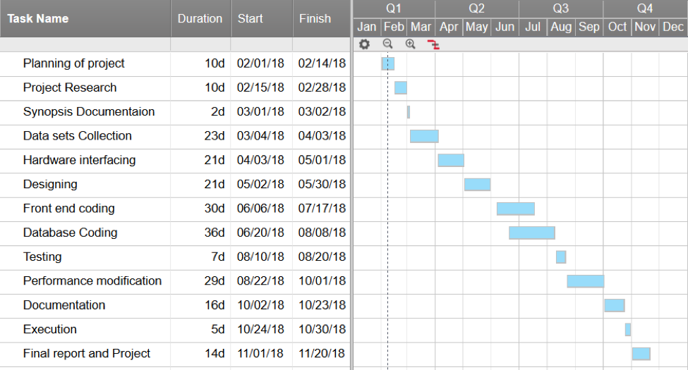

**Project Outcomes**

1. Virtual Pianos will reduce the problem of carrying large sized pianos.
2. Large Pianos are prone to damage in travelling and these Virtual Pianos will take care of this issue.
3. Virtual Pianos will be much cheaper than traditional pianos.
4. It will help young children to get a feel for music and will act as a stepping stone for some of the world’s greatest artists.

**References**

[1] E. Dawe and R. Green, "Computer Vision Piano Tutor," Canterbury University 2010.

[2] C. Deaker and R. Green, "A Computer Vision Method of Piano Tutoring, Without the Piano," Canterbury University 2011.

[3] F. Huang, Y. Zhou, Y. Yu, Z. Wang, and S. Du, "Piano AR: A Markerless Augmented Reality Based Piano Teaching System," in Intelligent Human-Machine Systems and Cybernetics (IHMSC), 2011 International Conference on, 2011, pp. 47-52.

[4] D. O. Gorodnichy and A. Yogeswaran, "Detection and tracking of pianist hands and fingers," in Computer and Robot Vision, 2006. The 3rd Canadian Conference on, 2006, pp. 63-63.

[5] A. Oka and M. Hashimoto, "Marker-less piano fingering recognition using sequential depth images," in Frontiers of Computer Vision, (FCV), 2013 19th Korea-Japan Joint Workshop on, 2013, pp. 1-4.

[6] C.-H. Yeh, W.-Y. Tseng, J.-C. Bai, R.-N. Yeh, S.-C. Wang, and P.-Y. Sung, "Virtual Piano Design via Single-View Video Based on Multifinger Actions Recognition," in Human-Centric Computing (HumanCom), 2010 3rd International Conference on, 2010, pp. 1-5.

[7] K. Huang, E. Y. L. Do, and T. Starner, "PianoTouch: A wearable haptic piano instruction system for passive learning of piano skills," in Wearable Computers, 2008. ISWC 2008. 12th IEEE International Symposium on, 2008, pp. 41-44.

[8] M. Lang and R. Green, "Musical Desktop: A Webcam Piano," Canterbury University 2012.

[9] C.-C. Lin and D. S.-M. Liu, "An intelligent virtual piano tutor," presented at the Proceedings of the 2006 ACM international conference on Virtual reality continuum and its applications, Hong Kong, China, 2006.

[10] M. Sotirios and P. Georgios, "Computer vision method for pianist's fingers information retrieval," presented at the Proceedings of the 10th International Conference on Information Integration and Web-based Applications & Services, Linz, Austria, 2008.

[11] J. Savard. (N.D., 04/05/2013). The Size of the Piano Keyboard [Online]. Available: http://www.quadibloc.com/other/cnv05.htm

[12] B. Kraemer. (N.D.). Major Piano Triad Chords [Online]. Available: http://piano.about.com/od/chordskeys/ss/major_triads_treble.htm

[13] R. Kelley. (2001, 04/05/2013). Scale Fingering Chart [Online]. Available: http://www.robertkelleyphd.com/scalfing.htm

[14] N. Wickham. (2010, 04/05/2013). Free Piano Scale Fingering Diagrams [Online]. Available: http://musicmattersblog.com/2010/04/06/free-pianoscale-fingering-diagrams/